FBLA pRESENTS
DRESS FOR SUCCESS thursday


Future Business Leaders of America encourages the young men and women of LCMR to look their finest!!
To participate, students should dress in their best business attire every week. This includes:
Men: Button down shirt, tie, and dress pants
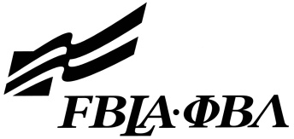
Women: Dress slacks or dresses

